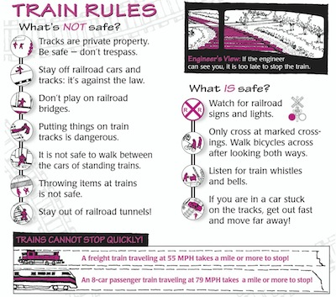

July 1st 4 pm – 8 pm at

SV Primary school

Fireworks at Dusk

Join us for an evening of family fun and entertainment.

There will be lots to do!

Try your luck at the cake walk. Play carnival games with the kids. Take a turn on the inflatable obstacle course for ages 8 and up. Ages 7 and under can enjoy time in the bounce house. See if you can hit the target with the dunk tank. Participate in the water balloon toss or get a team together for tug-of-war. Enjoy something to eat from one of the food trucks or 4 square youth group’s stand. Browse the Craft vendors. Buy a ticket for the basket raffle. Enjoy the Fireworks at Dusk

Celebrate

Independence Day

**VILLAGE BOARD MEETING SCHEDULE**

**June 26, 2023**

**July 24, 2023**

**August 28, 2023**

**September 25, 2023**

**October 23, 2023**

**November 27, 2023**

**December 18, 2023**

**Meetings start at 6:30 pm and**

**are open to the public to attend.**

**VILLAGE OF HARRISTOWN**

**MAYOR & BOARD MEMBERS**

EVELYN DEVERELL-MAYOR-619-3443

harristownmayor@gmail.com

TERESA ACREE-TRUSTEE-412-1579

[Carrosel5@yahoo.com](mailto:Carrosel5@yahoo.com)

DR. APRIL BOGAN-TRUSTEE-678-372-4720

Abogan2@aol.com

JEFF ELLER-TRUSTEE-855-0345

Jeller9@gmail.com

LES JENKINS-TRUSTEE-791-7147

Ljenkins5437@yahoo.com

JAY TRUSNER-TRUSTEE-217-791-2501

jaytrusner@comcast.net

KEVIN VESSELS-TRUSTEE-618-317-4550

kmvessels@gmail.com

**CLERK**-PENNY ALLEN

**TREASURER**-JULIE ROSE

**ATTORNEY**- ANDREW WEATHERFORD

**BUDGET OFFICER**-RICK LASKOWSKI

**BUILDING INSPECTOR**-RICK WATTS

**PLUMBING INSPECTOR-**SHAWN ZIEMER

**ZONING/PLANNING OFFICER**-MIKE SORRENTINO

**OFFICE STAFF-** MISTY PETERS

**PUBLIC WORKS DEPT**.

JONATHAN CLOSS

JEREMY EMBREY

**REMEMBER**

You can always email the Village directly from the website or by emailing

[harristownvillage01@gmail.com](mailto:harristownvillage01@gmail.com)

**CALENDAR OF EVENTS**

**\*\* Indicates Office Closed**

**July 1- Independence Day Fireworks**

**July 4-Independence Day\*\***

**August 26- Gold Cart Rally**

**September 4-Labor Day\*\***

**October 9-Columbus Day\*\***

**October 31-Trick or Treating 5-8pm**

**November 10-Veteran’s Day Observed\*\***

**November 24-Thanksgiving\*\***

**November 25-Day after Thanksgiving\*\***

**December 24- Christmas Eve**

**December 25- Christmas \*\***

**December 31- New Year’s Eve**

Sunday, June 18th

Brush collections will be **June 13th.**

**ALL** yard waste, including sticks and twigs under 2 foot, needs to be in bags. All branches need to be cut into 4 foot or less lengths.

Brush and yard waste MUST be by the curb.

The Harristown Community Involvement Committee is looking for volunteers to help at this year’s

Independence Day Celebration

July 1st.

We are currently looking for volunteers to help in the following areas:

Event set up 2pm

Game Attendants 4-6pm & 6-8pm

Dunk Tank Celebrities (20 minute time slots)

Celebration Cleanup Sunday

Contact Mindy Hood: call or text 217-454-8631 or email hoodonmain@gmail.com

(This is a good opportunity for those that need to earn community service hours.)

There have been several reports of kids playing on the railroad tracks in Harristown and even crawling between stopped train cars. Please make sure your child or teen knows how dangerous this can be.

The Village of Harristown is excited to welcome two new businesses.

**West Main Liquor & The Atterberry Market** are both officially open for business.

After many years serving on the Village of Harristown Zoning Board, Roger Trusner has decided to retire his position. He has been one of the longest serving members on the zoning board. We would like to thank Roger for all the time and effort he has put in to helping make the Village of Harristown a better place to live and work.

Brush Collection