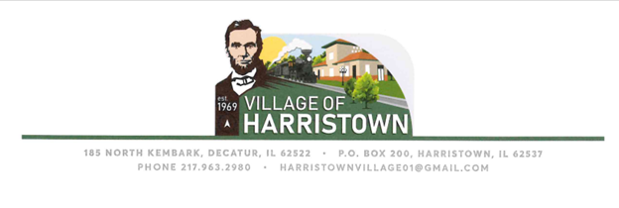

CONTRACT FOR WATER AND SEWER SERVICES

TODAY’S DATE:________________________________
DATE SERVICE TO START:________________________
PRIMARY RESIDENT NAME:____________________________________
SERVICE ADDRESS:___________________________________________
PHONE:___________________SECONDARY PHONE:________________
EMAIL:____________________________________________________
SOCIAL SECURITY NUMBER:_____________________
BIRTHDATE:__________________________________
EMPLOYER:_________________________________________________
OWN RENT
LANDLORD NAME:_______________________________
LANDLORD PHONE:_______________________________
MAILING ADDRESS (if different from service address):
______________________________________________________
OTHER CONTACT INFORMATION (if needed):
____________________________________________________________________________________________________________________
- This Agreement, when signed by the Applicant and by the Village of Harristown’s Agent, becomes a binding Contract. Under this Contract, the Village agrees to provide water and sewer services to the service location listed and the Applicant agrees to be responsible for receipt and payment of the bill for services. Any returned bills due to incorrect address, or any other reason, does not constitute reasonable excuse for non-payment. The Village shall only be responsible for the mailing of said bills to the address on file and shall not be responsible for its’ delivery to or receipt by the Applicant.
- Water and Sewer bills are mailed by the last day of each month. Payment is due upon receipt. If you have not received your bill by the 10th of the month, please contact the Village Office (217-963-2980) for your bill amount.
- If the bill is not paid by 3 PM on the 15th of the month, a 10% late fee will be added to the amount owed.
- If the bill is not paid (including late fee) by 3 PM on the 25th of the month, your account will be placed on the Shut-off list. If your water is shut off, a $35.00 reconnect fee will be added to your Account. The bill, including late fees and the shut off fee, must be paid in full before water service can be restored.
- The Applicant understands that a monthly minimum base charge will be billed each month, regardless of usage or not. The Village reserves the right to discontinue services if the Applicant breaches this Contract. If services are involuntarily disconnected for cause, the Applicant agrees to pay all outstanding charges and any applicable reconnection fees in order for services to be restored.
- The Village is responsible for maintaining water and sewer lines up to and including the meter. Maintenance of water and sewer lines from the meter to the residence or business is the responsibility of the property owner.
- It is a criminal offense to tamper with a water meter or fire hydrant. The Village of Harristown reserves the right to press criminal charges if tampering occurs.
- If a check, for any reason, is returned to the Village the amount of the check and a $30.00 Non-sufficient funds fee will be required.
- If you move from this address, you agree to contact the Village via phone, email, in person or with written notice. You must provide the date of disconnection, your forwarding address for final billing and a phone number. You also understand that you are responsible for the water and sewer billing until the Village of Harristown receives disconnection notice.
By signing this Agreement, you agree to all the terms in this Water and Sewer Agreement. You also are stating that you have read the Agreement and agree to accept all terms and conditions.
____________________________________ ______________________________________
Applicant Signature Village of Harristown, Agent
____________________________________ ______________________________________
Date Date

